Zero Trust Network Access (ZTNA) with Zscaler: Securing User-to-Application Connectivity.

Team Leader
R.DivyaSritha-2322j0717

Team Members
S. Aishwarya-2322j0715
G P .Danusiya-2322j0716
A Y. Farhan Jameela-2322j0718

Project details

Title: Zero Trust Network Access (ZTNA) with Zscaler: Securing User-to-Application Connectivity

• AI-Enhanced User Protection (AIUP)

AI-Enhanced User Protection (AIUP) is a modern security framework that uses artificial intelligence and machine learning to verify user identities and protect online platforms from cyber threats. Unlike traditional security systems that rely only on passwords or two-factor authentication, AIUP continuously monitors user behavior. It analyzes patterns such as login time, device usage, location, and interaction style. Based on these patterns, the system generates a dynamic trust score for each user. This score is continuously updated throughout the user’s session. AIUP helps detect unusual or suspicious activities quickly. It also addresses the weaknesses of traditional perimeter-based security systems. Modern attackers often use phishing, stolen credentials, and social engineering to gain access. By focusing on behavioral identity, AIUP verifies who the user truly is. This approach helps organizations prevent account takeovers, reduce fraud, and improve overall cybersecurity.
Abstract:
Traditional VPN architectures are often inadequate for handling modern cybersecurity threats such as lateral movement and excessive network access. To address these challenges, organizations are adopting Zero Trust security principles that focus on strict identity verification. This project focuses on the design and implementation of a Zero Trust Network Access (ZTNA) solution using Zscaler Private Access in a large institutional network. The main objective is to replace broad network-level access with secure, application-specific connectivity. App Connectors are deployed within the data center to enable secure communication between users and internal applications. The system is integrated with an identity provider such as Microsoft Azure Active Directory to authenticate users before granting access. All user-to-application connections are established through a secure cloud-based broker. This architecture makes internal applications invisible to the public internet, reducing the attack surface. The project also integrates security monitoring using IBM QRadar and threat intelligence from Malware Information Sharing Platform. As a result, the framework enforces least-privilege access, improves monitoring, and strengthens the organization’s overall security posture.

Use Case Scenarios:

Scenario 1: Secure Remote ERP Access for Faculty
A faculty member working remotely from home needs to log into the university’s ERP platform to upload and update student grades. By using Zscaler Private Access, the faculty member gains secure access without directly joining the internal university network. The system first confirms the user’s identity through multi-factor authentication provided by Microsoft Azure Active Directory and then checks whether the device meets security requirements before granting access.
Output:
• Faculty identity successfully authenticated (Faculty_Group)
• Device security status verified (Antivirus enabled, operating system updated)
• Secure micro-tunnel connection created only for the ERP application
• Internal network infrastructure remains hidden from the user

Scenario 2: Limited Database Access for External Researcher
A research collaborator from another institution needs temporary permission to use a specific research database hosted on the university’s servers. The administrator configures a time-restricted and application-specific access policy through Zscaler Private Access. The researcher is able to access only the approved database while the rest of the university’s internal systems remain inaccessible.
Output:
• External researcher identity verified using temporary login credentials
• Security policy applied (7-day duration, access limited to Research-DB)
• Database server remains invisible to internet scanning tools
• User session automatically ends once the access policy expires

Scenario 3: Student Access to Online Examination Portal
During final examination periods, thousands of students log into the university’s internal online exam portal from different locations. Zscaler Private Access ensures that only authenticated students using secure devices can reach the examination server. The cloud-based system efficiently manages large numbers of simultaneous logins while also protecting the portal from threats such as DDoS attacks or unauthorized attempts to reach other internal resources.
Output:
• Large-scale user authentication handled through cloud scalability
• Each student receives access only to the examination application

- Lateral movement to grade database or other servers blocked
- Exam server IP address remains concealed from the internet

Scenario 4: IT Administrator Conducting Server Maintenance
An IT administrator is required to perform important updates on an internal application server. Instead of using a traditional VPN connection that provides full network access, the administrator securely connects through Zscaler Private Access directly to the server’s management interface. The platform continuously monitors the session activity in real time to ensure secure operations. If any unusual behavior occurs, such as attempts to access other unauthorized servers, the system automatically blocks the activity and terminates the session.
Output:
• Administrator identity authenticated using multi-factor authentication
• Secure micro-tunnel created only for the Server-Management-Interface
• All administrative commands and keystrokes recorded for auditing
• Unauthorized attempt to connect to another server instantly blocked

Scenario 5: Temporary Contractor Access During System Upgrade
During a university system upgrade project, a contractor is hired to migrate data from a specific file server. Using Zscaler Private Access, the contractor is provided with limited access only to the required server without adding them to the university’s main directory services or giving VPN credentials. The access permission is configured to automatically expire once the project timeline is completed.
Output:
• Contractor identity validated through a separate identity provider integration
• Permission granted only to the File-Server-Migration shared resource
• All file movement and transfer activities recorded in Zscaler and SIEM systems
• Access rights automatically disabled after the 30-day project completion period

Stage-1

Title Of the Project: -

Zero Trust Network Access (ZTNA) with Zscaler: Securing User-to-Application Connectivity.

Overview: -

The project focuses on developing an AI-based identity verification system to improve online security by analysing user behaviour patterns. The system uses machine learning techniques to create behavioural profiles that help distinguish legitimate users from suspicious activities. This approach helps prevent unauthorized access, fraud, and cyber threats across various online platforms and services.

The main objective of the system is to enhance security by validating user identities based on their online behaviour. Advanced technologies such as deep learning, neural networks, and natural language processing are used to build adaptive behavioural profiles that evolve with user activity.

To strengthen security, the system includes multi-factor authentication that activates additional verification when suspicious activity is detected. Alert mechanisms notify both users and administrators about potential risks. Secure data storage and management components are implemented to protect sensitive behavioural data and system information.

The system also provides integration capabilities with various online platforms and services. Monitoring and reporting features help track performance and security activities. Scalability and load balancing are included to support a growing number of users while maintaining system efficiency and reliability.

Cloud infrastructure can be used to improve flexibility and scalability. Continuous training of machine learning models helps the system adapt to evolving threats. Deploying components across multiple regions can also improve system reliability and performance.
Multi-factor verification is also implemented to bolster security, triggering additional verification steps when anomalies are detected. User and administrator alerts ensure transparent communication and provide guidance on resolving potential security issues. Secure data storage and management components are included to protect sensitive user profiles and anomaly data.

The system includes an integration layer for seamless interaction with various online platforms and services. Monitoring and reporting are integrated for performance and security, providing transparency and accountability. Scalability and load balancing are designed to handle growing user bases, while security and compliance are prioritised by encrypting data in transit and at rest, employing firewalls, intrusion detection systems, and adhering to data protection and privacy regulations.

Cloud infrastructure is an optional option for flexibility and scalability. Continuous training and optimization of machine learning models ensure the system remains effective against evolving threats and user behaviours. Geographic distribution can enhance redundancy and performance by deploying components in multiple geographic

List of Vulnerability Table:

Practice Website:

S.no | Vulnerability Name | CWE - No
1 | Improper Sanitization of File Paths | CWE- 284: Improper Access  Control
2 | Invalid Certificate | CWE-395: Improper  Certificate Validation
3 | Missing X-Frame-Options Header | CWE-1021: Design  Improper Restriction of  Rendered UI Layers or  Frames
4 | X-Content-Type Options Header Missing | CWE -918: Server-Side  Request Forgery (SSRF)
5 | Drupal Ajax API shows JSONP not disabled by default | CWE-937,1035: OWASP  Top Ten 2013,2017 Category A9 - Using Components with  Known Vulnerabilities

6 | Drupal Api Vulnerability | CWE-20: Improper Input  Validation
7 | Improper API Filtration | CWE-79: Improper  Neutralisation of Input  During Web Page Generation  ('Cross-site Scripting')
8 | Denial of Service | CWE -400: Uncontrolled  Resource Consumption
9 | TLS Version 1.0 Protocol Detection | CWE-327: Use of a Broken or Risky Cryptographic  Algorithm
10 | web.config File Information Disclosure | CWE-497: Exposure of Sensitive System Information to an Unauthorised Control  Sphere

Main Website:

S.no | Vulnerability Name | CWE - No
1 | SL Medium Strength Cipher Suites Supported  (SWEET32) | CWE-200: Exposure of  Sensitive Information to an  Unauthorised Actor
2 | Cookie SERVERID created without secure flag | CWE-79: Improper  Neutralisation of Input During  Web Page Generation
3 | X-Content-Type Options Header Missing | CWE-918: Server-Side  Request Forgery (SSRF)
4 | Denial of Service | CWE -400: Uncontrolled  Resource Consumption
5 | OS Identification | CWE-200: Exposure of  Sensitive Information to an  Unauthorised Actor

REPORT: -
Practice Website: https://www.hackthebox.com/

Vulnerability Name: Improper File Path Validation – CWE-284: Improper Access Control

OWASP Category: A01:2021 – Broken Access Control

Description: This vulnerability arises when an application fails to properly validate or limit access to file paths within the system. Due to weak or incorrect access control mechanisms, unauthorized users may be able to reach restricted files or resources. Attackers can exploit this weakness to bypass normal security restrictions and view or manipulate sensitive directories or data.
Business Impact: This vulnerability is significant, as it can lead to unauthorized access to sensitive data or files, potentially causing data breaches, privacy violations, and loss of user trust.
Affected sites may also require configuration changes after applying a security release.
Steps to Reproduce: https://www.shodan.io/host/31.3.96.40

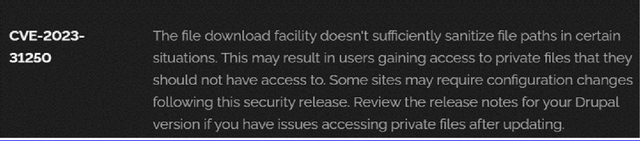

Recommendation:

- Install Security Patches: The main recommendation is to install the security patch released by Drupal as soon as it is available. These updates usually contain fixes that resolve known vulnerabilities and improve overall system security.
- Check System Configuration: After installing the update, review the configuration of the Drupal website to ensure that private files and sensitive resources are properly secured. Adjust file permissions and access control settings if required.
- Perform Regular Security Checks: Carry out periodic security audits and vulnerability scans to detect and fix potential weaknesses in the Drupal website and maintain a strong security posture.
.
- Access Control: Implement strong access controls to ensure that only authorized users can access private files. Review and restrict file access permissions as needed.
- Data Minimization: Minimize the amount of sensitive data stored on your Drupal site. Only store data that is necessary for your site's functionality.

2) Vulnerability Name: Invalid Certificate
CWE-395: Improper Certificate Validation

OWASP Category: A07:2021 – Identification and Authentication Failures

Description: When a digital certificate is invalid, untrusted, or malicious, it can allow attackers to impersonate a legitimate entity by interfering with the communication between a client and a host. In such situations, the system may unknowingly establish a connection with a malicious server while assuming it is a trusted one. This weakness can also cause the system to accept forged or manipulated data that appears to originate from a legitimate and trusted source.
Business Impact: Weak or improper certificate validation can expose systems to several security risks. One major risk is Man-in-the-Middle (MITM) attacks, where attackers intercept communication between two parties and may read, alter, or manipulate the exchanged data. It can also result in data breaches, where unauthorized individuals gain access to confidential information or critical systems. Additionally, attackers may exploit fake certificates to distribute malware, allowing them to spread malicious software or compromise user devices and networks.
Steps to Reproduce: https://www.ssllabs.com/ssltest/?utm_source=chatgpt.com

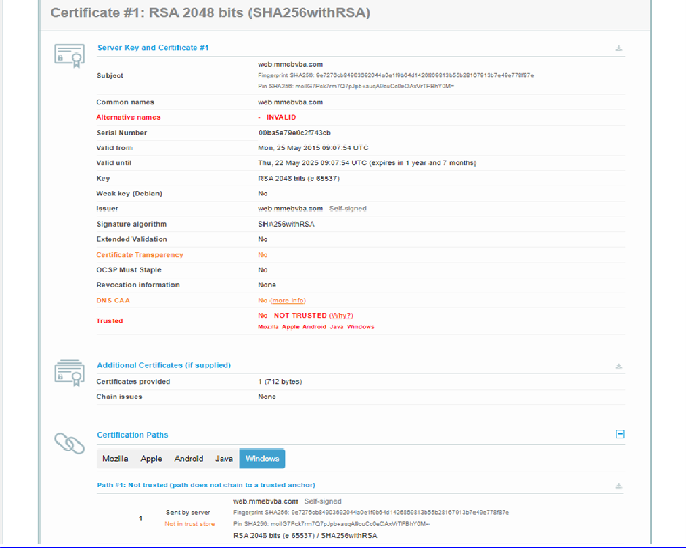
Recommendation:

- Use trusted certificate authorities: Only trust digital certificates issued by well-known and trusted certificate authorities.
- Verify certificate chains: Verify that the certificate presented by the remote party is valid and issued by a trusted certificate authority. Verify the entire certificate chain, including intermediate certificates.
- Check certificate revocation status: Check the revocation status of the certificate presented by the remote party to ensure that it has not been revoked.
- Use certificate pinning: Implement certificate pinning to ensure that the communication only occurs with the exact certificate or certificate authority specified.
- Keep software up to date: Keep software and security protocols up to date, as new vulnerabilities and security patches are regularly released.

3) Vulnerability Name: Missing X-Frame-Options Header

CWE-1021: Design Improper Restriction of Rendered UI Layers or Frames

OWASP Category: A04:2021-Insecure Design

Description: A web application should enforce security controls that prevent it from being displayed inside frames, iframes, objects, embed, or applet elements on other websites. If these protections are not implemented, attackers may load the application within a malicious webpage and trick users into interacting with it unknowingly. This type of attack can mislead users into performing actions they did not intend.
Business Impact: This enables path to the attackers to manipulate or gain unauthorized access to user interface elements, potentially leading to deceptive or malicious user interactions. This can result in data leakage, fraud, user distrust, and reputational damage, undermining the integrity and trustworthiness of the application and causing financial losses.
Vulnerability Path: http://www.itsecgames.com/

Steps to Reproduce:

- Open the practice website to inspect
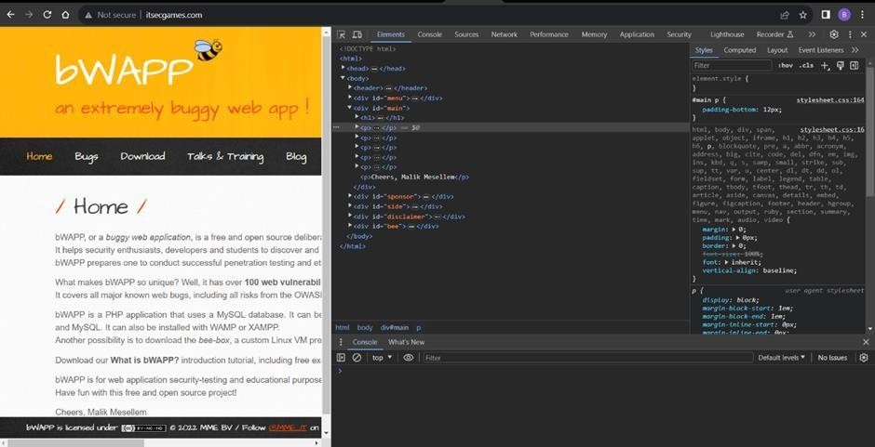

- Go to network and start capturing using F5 or Ctrl+R

- Go to html document and see if x-frame-options present in response headers or not

- If not the absence of this header indicates that the website may not have protection against embedding its content within an iframe on other domains, potentially leaving it vulnerable to clickjacking attacks.

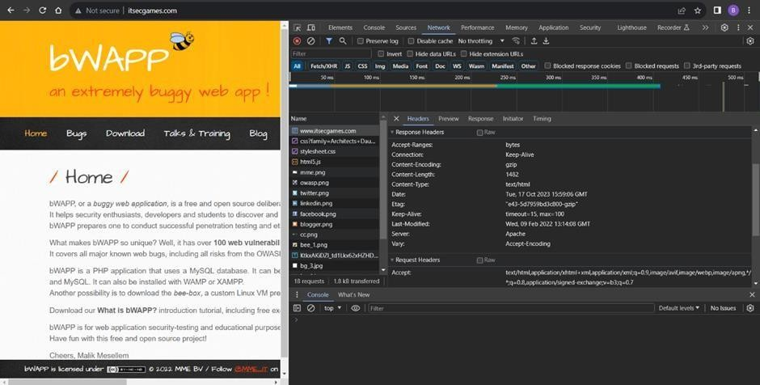
Recommendation:

- Implement Proper UI Layer Access Controls: Enforce access controls to restrict access to UI layers or frames based on user privileges.
- Use Session and Authentication Management: Ensure robust session management and user authentication mechanisms to prevent unauthorized access.
- Implement Content Security Policies (CSP): Use CSP headers to control where resources can be loaded from and mitigate against frame-based attacks.
- Keep Software and Libraries Updated: Stay current with software updates and patches to address known security issues.

4) Vulnerability Name: X-Content-Type Options Header Missing CWE -918: Server-Side Request Forgery (SSRF)
OWASP Category: A10:2021 – Server-Side Request Forgery (SSRF)

Description: The web server receives a URL or similar request from an upstream component and retrieves the contents of this URL, but it does not sufficiently ensure that the request is being sent to the expected destination.

Business Impact: The absence of this security header can expose the application to several risks. Attackers may force the server to interpret sensitive information as HTML content, which can result in unintended data exposure. Content type manipulation may also increase overall security vulnerabilities, potentially allowing breaches, data leaks, or unauthorized system access. Additionally, if such vulnerabilities are successfully exploited, it can negatively affect the organization’s brand image and reputation, reducing user trust and confidence in the system.
https://securityheaders.com/?q=http%3A%2F%2Fwww.itsecgames.com%2F&followRedirects= on
Steps to Reproduce:
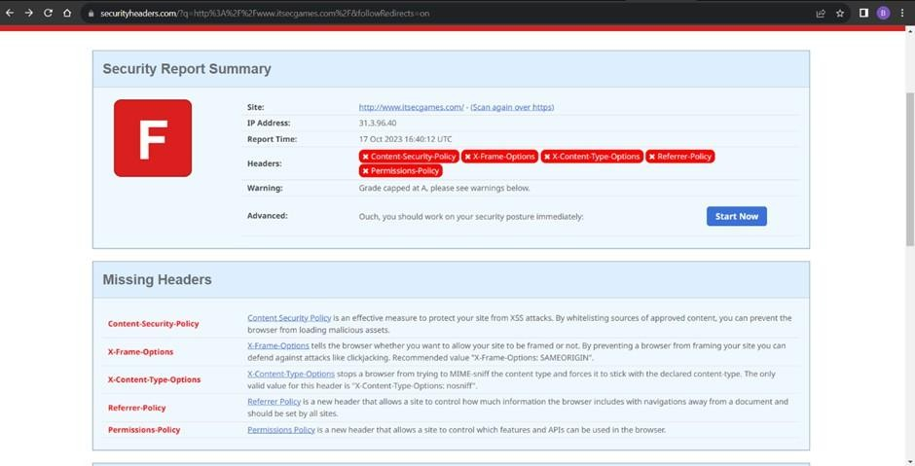

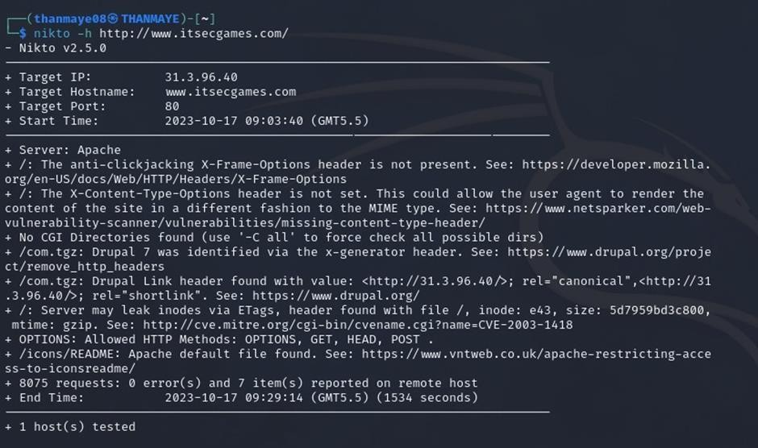
Recommendation:

- Implement "X-Content-Type-Options" Header: Configure the "X-Content-Type-Options" header with the value "nosniff" in your web server or application to prevent content type sniffing.
- Secure SSRF: To directly mitigate SSRF vulnerabilities, ensure proper input validation, access controls, and allow-list-based URL validation to prevent attackers from making unauthorized requests to internal resources.
- Security Headers: Implement other security headers like "X-Frame-Options" and "Content-Security-Policy" to further enhance security and mitigate various types of web-based attacks.
While the "X-Content-Type-Options" header may not be a direct countermeasure to SSRF, it is a valuable security control that, when configured correctly, can help protect against content type- based attacks that may be exploited in SSRF scenarios.

5) Vulnerability Name: Drupal Ajax API shows JSONP not disabled by default

CWE-937,1035: OWASP Top Ten 2013,2017 Category A9 - Using Components with Known
Vulnerabilities
OWASP Category: A06:2021-Vulnerable and Outdated Components

Description: Vulnerable and outdated components occur when a web application uses software libraries, frameworks, plugins, or dependencies that contain known security flaws or have not been updated to secure versions. These components may no longer be maintained by developers or may have publicly disclosed vulnerabilities that attackers can exploit. Using such outdated or insecure modules increases the risk of security weaknesses within the application..
Business Impact: The presence of vulnerable and outdated components in a web application poses significant security risks. Attackers can exploit these weaknesses to gain unauthorized access, inject malicious code, steal sensitive data, or disrupt the system's operation. The potential business impacts include compromised user data, damaged reputation, legal consequences, and financial losses due to breach recovery and remediation efforts.
Vulnerability Path: https://www.shodan.io/host/31.3.96.40

Steps to Reproduce:

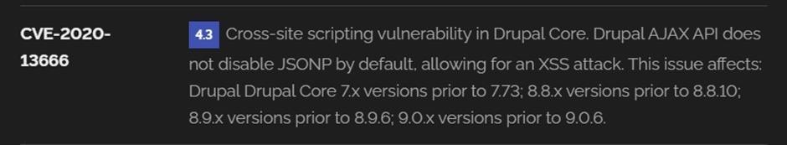

Recommendation:
- Regular Updates: Keep all components, libraries, and dependencies up to date by applying security patches and upgrades.
- Vulnerability Scanning: Conduct periodic vulnerability assessments to identify and address potential issues.
- Dependency Management: Implement a strategy for managing third-party dependencies, including continuous monitoring of their security status.
- Security Testing: Perform regular security testing, including penetration testing and code review, to identify and remediate vulnerabilities.
- Change Control: Maintain a change management process to assess the impact of new components and ensure they don't introduce new vulnerabilities.

6) Vulnerability Name: Drupal Api Vulnerability
CWE-20: Improper Input Validation
OWASP Category: A03:2021 – Injection

Description: The product receives input or data, but it does not validate or incorrectly validates that the input has the properties that are required to process the data safely and correctly.
Business Impact: A successful SQL injection attack can have severe consequences for organizations. It may allow attackers to access confidential data without authorization, steal important information, and cause financial damage. Such attacks can also harm the organization’s reputation and lead to legal penalties. In many cases, SQL injection incidents may result in compliance violations, loss of customer confidence, and disruptions to normal business operations.
Vulnerability Path: https://www.shodan.io/host/31.3.96.40

Steps to Reproduce:

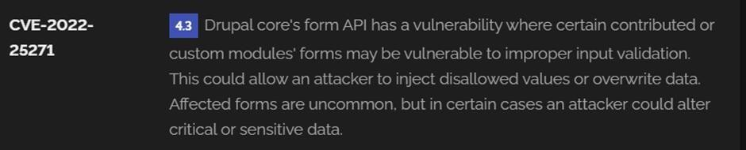

Recommendation:
- Input Validation: Implement rigorous input validation on all user inputs and ensure that only safe, sanitized data is passed to the database.
- Parameterized Queries: Use parameterized queries or prepared statements to separate SQL code from user input, preventing malicious injections.
- Escaping User Input: If parameterized queries are not feasible, escape user input before incorporating it into SQL queries to neutralize special characters.
- Least Privilege Principle: Limit the permissions and access rights of database accounts to the minimum required for specific tasks to minimize the potential damage of an attack.
- Web Application Firewalls (WAF): Employ WAFs to filter and block malicious SQL injection attempts.
- Regular Security Testing: Conduct regular security assessments, including penetration testing, to identify and address vulnerabilities.

7) Vulnerability Name: Improper API Filtration

CWE-79: Improper Neutralization of Input During Web Page Generation ('Cross-site Scripting')

OWASP Category: A07-2017: Cross-site Scripting (XSS)

Description: The product does not neutralize or incorrectly neutralizes user-controllable input before it is placed in output that is used as a web page that is served to other users.
Business Impact: If this vulnerability is exploited, attackers can insert harmful scripts into web pages that are later executed in the browsers of other users. These scripts may be used to steal sensitive information or perform actions on behalf of the user without their knowledge. Such attacks can lead to unauthorized access, compromised user accounts, and exposure of confidential data. Attackers may obtain credentials, personal information, or financial details, which could result in regulatory violations and legal responsibilities.
Vulnerability Path: https://www.shodan.io/host/31.3.96.40 Steps to Reproduce:
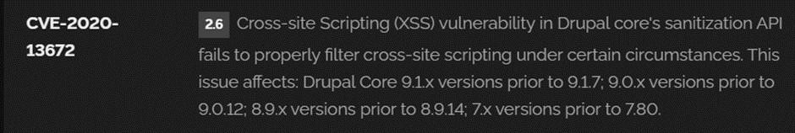

Recommendation:

- Update and Patch: Ensure that Drupal and all related modules and components are up to date with the latest security patches to mitigate known vulnerabilities.
- Input Validation: Implement strong input validation and output encoding to sanitize user inputs and prevent the injection of malicious scripts.
- Content Security Policy (CSP): Implement CSP headers to restrict the sources from which content can be loaded, reducing the risk of XSS.
- Secure Coding Practices: Train developers in secure coding practices, emphasizing the importance of validating and escaping user inputs.
- Security Scanning: Conduct regular security scans and penetration tests to identify and address XSS vulnerabilities.

8) Vulnerability Name: Denial of Service

CWE -400: Uncontrolled Resource Consumption

OWASP Category:

Description: A Denial of Service (DoS) attack is intended to make a system, website, application, or server unavailable to legitimate users. Attackers achieve this by overwhelming the target with a large number of requests or by exploiting weaknesses in network protocols, application logic, or resource management. When a system receives excessive traffic or abnormal requests, it may become slow or completely unable to respond to legitimate users. In some cases, attackers may also exploit software vulnerabilities or improper resource handling to disrupt the service.
In certain situations, attackers may inject or execute malicious code during a DoS attack to gain access to sensitive information or perform unauthorized actions on the server. These attacks greatly reduce the quality of service experienced by legitimate users by causing long response times, packet losses, and interruptions in service availability. As a result, DoS attacks can significantly affect system performance and reliability, directly impacting the availability of online services.
Business Impact: If this vulnerability is successfully exploited, attackers can overwhelm a system or application by generating excessive requests and consuming critical resources. This may cause the system to slow down significantly or become completely unavailable to legitimate users. Important resources such as CPU, memory, and network bandwidth may be exhausted, leading to degraded system performance or even system crashes. In severe cases, this can result in service interruptions and possible data loss. Such disruptions can negatively affect business operations, reduce productivity, and lead to financial losses. Additionally, repeated service outages can damage the organization’s reputation and weaken customer trust. Organizations may also face regulatory or compliance issues if service disruptions violate established service standards. To reduce these risks, proper resource management, continuous monitoring, and effective incident response planning are necessary to maintain system availability and service reliability.Steps to Reproduce: exploit open ports 80 to perform SQL injections, cross-site request forgeries and DDoS attacks.
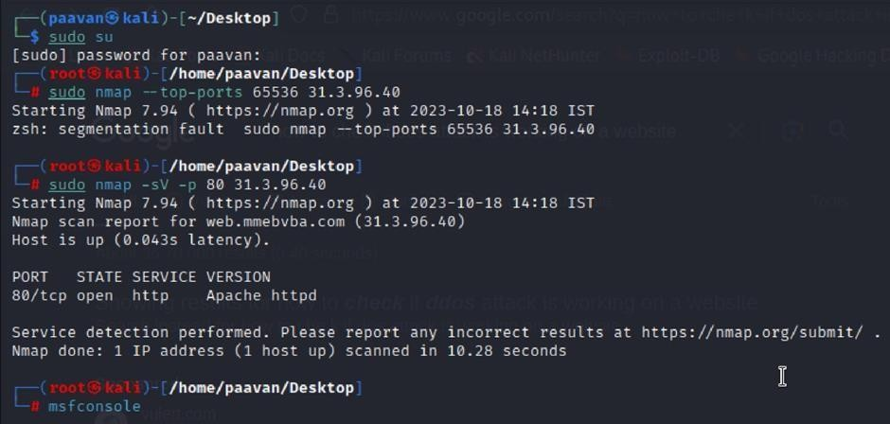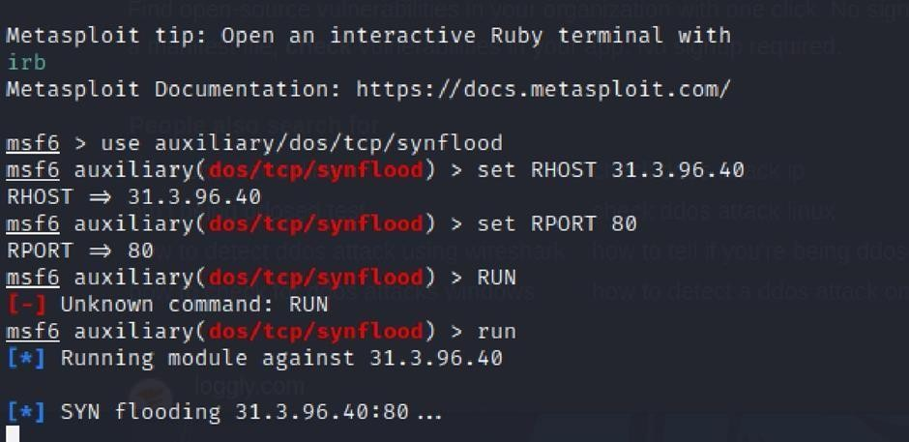
Recommendation: Implement a strong Web Application Firewall (WAF) to monitor, filter, and block suspicious traffic targeting port 80. The firewall should be configured to detect and prevent excessive requests or traffic patterns that indicate possible attacks. Load balancing can also be used to distribute incoming traffic across multiple servers, preventing any single server from becoming overloaded. In addition, rate limiting and throttling mechanisms should be applied to control the number of requests that a single IP address can send within a specific time period. Continuous monitoring of network traffic and the use of alert systems can help identify unusual spikes in activity and allow quick response to potential threats. Regularly updating software and systems with the latest security patches is also important to fix known vulnerabilities that attackers might exploit.

9) Vulnerability Name: TLS Version 1.0 Protocol Detection
CWE-327: Use of a Broken or Risky Cryptographic Algorithm
OWASP Category: A02:2021-Cryptographic Failures
Description: The product uses a broken or risky cryptographic algorithm or protocol.

Business Impact: TLS 1.0 is an outdated encryption protocol that contains known security weaknesses, making it unsafe for protecting sensitive data. Its continued use can expose important information such as customer details and payment data to potential cyber threats.

Steps to Reproduce:

- Open a terminal or command prompt

- Type the Command: openssl s_client -connect 31.3.96.40:443 -tls1

- The connection is successfully means the server supports TLS 1.0
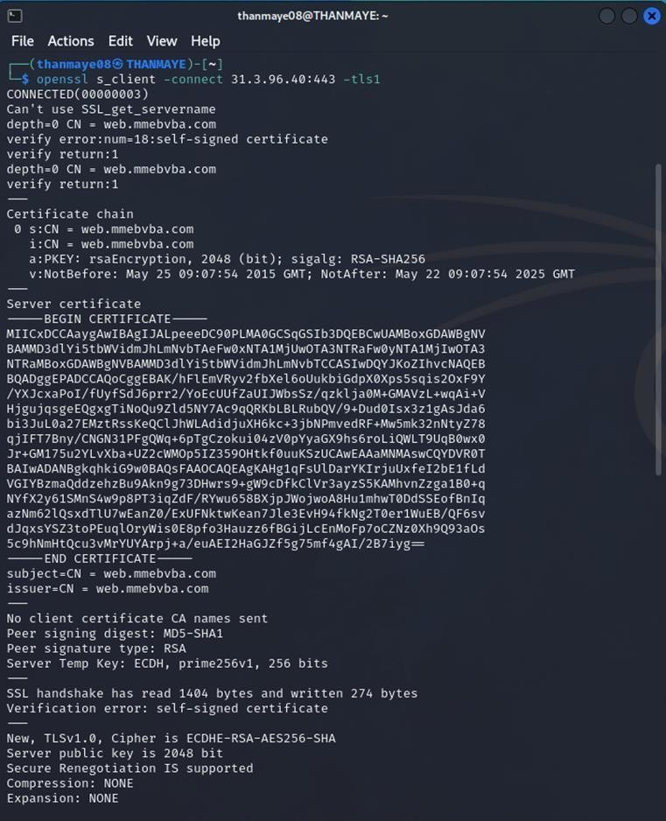
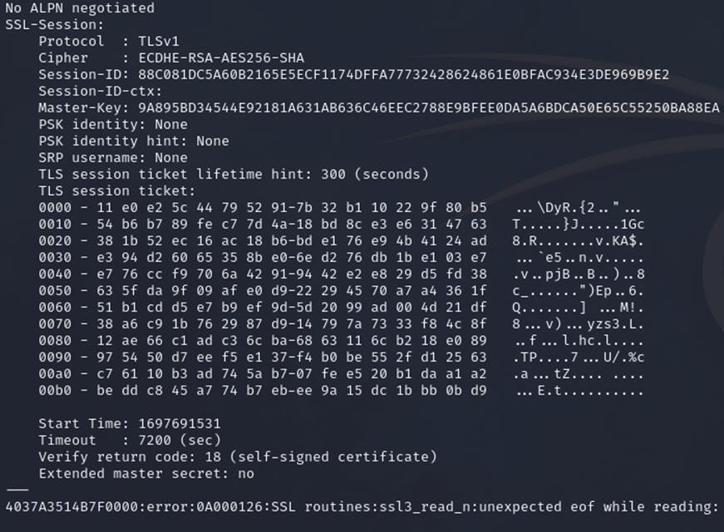

Recommendation:

- Upgrade to a Secure TLS Version: Transition to a more secure TLS version, such as TLS 1.2 or TLS 1.3. This will provide stronger encryption and improved security against modern threats.
- Regularly Update SSL/TLS Configuration: Keep your SSL/TLS configuration up to date to ensure it aligns with the latest security best practices and vulnerabilities.
- Implement a Strong Cryptographic Suite: Use strong cipher suites and secure configurations to further enhance security. Disable weak ciphers and outdated protocols.
- Compliance Checks: Ensure that your website complies with relevant data protection regulations and industry standards (e.g., GDPR, PCI DSS) to avoid legal issues.

10) Vulnerability Name: web.config File Information Disclosure

CWE-497: Exposure of Sensitive System Information to an Unauthorized Control Sphere

OWASP Category: A3:2017-Sensitive Data Exposure
Description: An information disclosure vulnerability exists in the remote web server because the web.config file is publicly accessible. An unauthenticated remote attacker can exploit this issue by sending a simple GET request to retrieve the file, which may reveal sensitive configuration information stored within the server.
Business Impact: Exposure of the web.config file can reveal important details such as database connection strings, authentication settings, and encryption keys. Attackers can use this information to gain unauthorized access to systems, perform data breaches, or compromise the application environment. Such incidents may result in financial losses, reputational damage, and legal consequences, while also reducing customer trust in the organization’s security practices.
Steps to Reproduce:

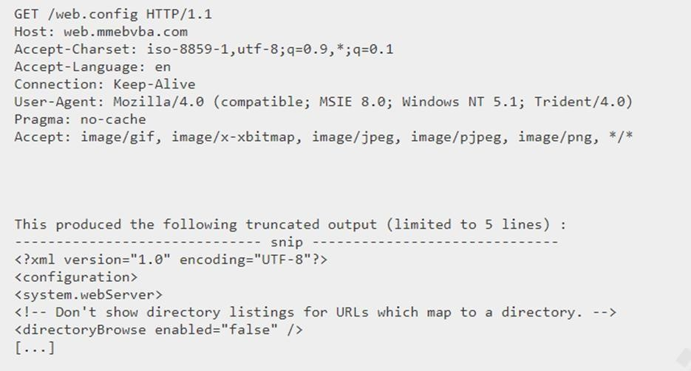

Recommendation:

- Implement proper access controls to restrict access to the web.config file.
- Prevent directory traversal and ensure the web.config file cannot be directly accessed through the web server.
- Encrypt sensitive data within the configuration file.
- Regularly review and update the web.config file, removing any unnecessary sensitive information.
- Ensure that the web.config file is properly secured and not accessible to unauthorized users.
Main Website: vtop.vit.ac.in

1) Vulnerability Name: SL Medium Strength Cipher Suites Supported (SWEET32)
CWE-200: Exposure of Sensitive Information to an Unauthorised Actor
OWASP Category: Broken access control

Description: The remote host is configured to support SSL cipher suites that provide only medium-strength encryption. Security scanners such as Nessus classify medium-strength encryption as cipher suites that use key lengths of at least 64 bits but less than 112 bits, or those that rely on the 3DES encryption algorithm. Using these weaker encryption methods may reduce the overall security of the communication channel and can make the system more vulnerable to potential cryptographic attacks.
Note that it is considerably easier to circumvent medium strength encryption if the attacker is on the same physical network.
Business Impact: The SWEET32 vulnerability refers to the use of outdated cryptographic cipher suites that rely on 64-bit block sizes in SSL and TLS protocols. These cipher suites are vulnerable to birthday attacks, where repeated encrypted data blocks may eventually collide after many transmissions. When this occurs, attackers may be able to analyze the encrypted traffic and potentially recover sensitive information. If an organization’s systems still support these legacy cipher suites, encrypted communications could be intercepted, altered, or misused by attackers. This can result in unauthorized access, data theft, or even the insertion of malicious content into secure communications. Such risks threaten the confidentiality and integrity of sensitive business information and may damage organizational security. To reduce this risk, systems should be updated to use stronger cipher suites with larger block sizes and modern encryption standards. Addressing this vulnerability helps strengthen overall security, while failing to resolve it may leave organizations exposed to advanced cyberattacks and possible legal or regulatory consequences in the event of a data breach.
Vulnerability Path : The Sweet32 vulnerability when detected with a vulnerability scanner will report it as a CVSS 7.5.
Steps to Reproduce:
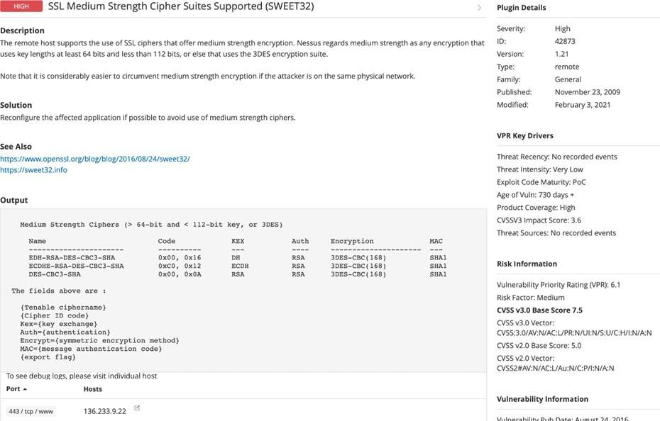
Recommendation: organisations should take several proactive steps. Firstly, it is crucial to update and configure cryptographic libraries, web servers, and any network devices to disable support for cipher suites with 64-bit block sizes. This can be achieved by ensuring that only modern and secure cipher suites are enabled in the TLS/SSL configurations. Additionally, organizations should regularly monitor and assess their systems for any outdated or vulnerable protocols and promptly apply security patches and updates. Implementing strong, unique encryption keys and employing forward secrecy protocols can further bolster security. It's also recommended to utilize intrusion detection systems and perform regular security audits to identify and address any potential vulnerabilities promptly. Lastly, organizations should stay informed about emerging security threats and best practices in cryptographic protocols to proactively adapt their security measures. By taking these measures, businesses can significantly reduce the risk of falling victim to SWEET32 attacks and enhance the overall security of their digital infrastructure.

2) Vulnerability Name: Cookie SERVERID created without secue flag
CWE-79: Improper Neutralization of Input During Web Page Generation
OWASP Category: A07-2017: Cross-site Scripting
Description: The vulnerability allows an attacker to inject malicious code into a WordPress website, which can then be executed by visitors to the website.
To exploit this vulnerability, an attacker would simply need to trick a user into clicking on a malicious link or opening a malicious attachment. Once the user clicks on the link or opens the attachment, the attacker's code would be executed, giving the attacker control over the user's account and potentially the entire WordPress website.
Business Impact: The business impact of Cross-Site Scripting (XSS) attacks can be significant, affecting both security and reputation. Such attacks may lead to loss of customer trust if sensitive information is compromised. In serious cases, organizations may also face legal consequences due to data breaches. Financial losses can occur through fraudulent activities or the costs associated with fixing the vulnerability and strengthening security systems. Over time, customers may stop using the platform if they believe it is not secure, which can further harm the organization’s growth. To reduce the risk of CWE-79 vulnerabilities, organizations should apply strong input validation and proper output encoding techniques, while continuously monitoring for new web security threats. Ignoring XSS vulnerabilities can lead to serious damage to both the organization’s reputation and financial stability.
Vulnerability Path: https://securityheaders.com/

Steps to Reproduce:

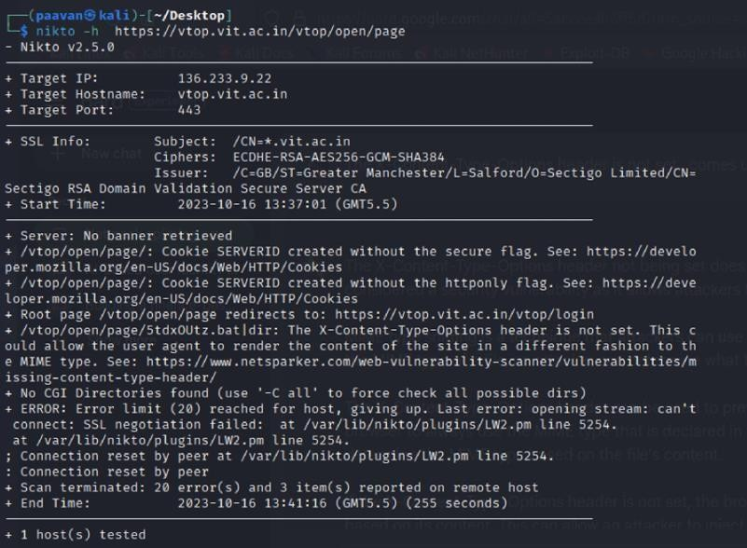

Recommendation:

- Update and Patch: Ensure that Drupal and all related modules and components are up to date with the latest security patches to mitigate known vulnerabilities.
- Input Validation: Implement strong input validation and output encoding to sanitize user inputs and prevent the injection of malicious scripts.
- Content Security Policy (CSP): Implement CSP headers to restrict the sources from which content can be loaded, reducing the risk of XSS.
- Secure Coding Practices: Train developers in secure coding practices, emphasizing the importance of validating and escaping user inputs.
- Security Scanning: Perform regular security assessments and penetration testing to detect and resolve Cross-Site Scripting (XSS) vulnerabilities.

3) Vulnerability Name: X-Content-Type Options Header Missing
CWE-918: Server-Side Request Forgery (SSRF)
OWASP Category: A10:2021 – Server-Side Request Forgery (SSRF)

Description: The absence of the X-Content-Type-Options header creates a security risk for web applications. This header is an important protection mechanism that instructs browsers to strictly follow the MIME type specified in the Content-Type header instead of attempting to determine the file type automatically. When this header is missing, browsers may try to guess the content type, which can lead to MIME-sniffing attacks. Attackers may exploit this behavior by disguising malicious content, such as scripts or executable files, as harmless files. This can potentially result in Cross-Site Scripting (XSS) or other security threats. To reduce this risk, the X-Content-Type-Options header should be implemented with the value "nosniff", ensuring that browsers process files only according to the declared content type and improving the overall security of the web application.
Business Impact: The absence of this security header can create several security risks for the application. Attackers may force the server to display sensitive information as HTML content, which can lead to data exposure. Manipulation of content types can also increase security vulnerabilities and may result in system breaches, data leaks, or unauthorized access. In addition, successful exploitation of such weaknesses can damage the organization’s brand image and reputation, reducing user trust and confidence in the security of the system.
Vulnerability Path : https://securityheaders.com/?q=http%3A%2F%2Fvtop.vit.ac.in%2F&followRedirects=on

Steps to Reproduce:
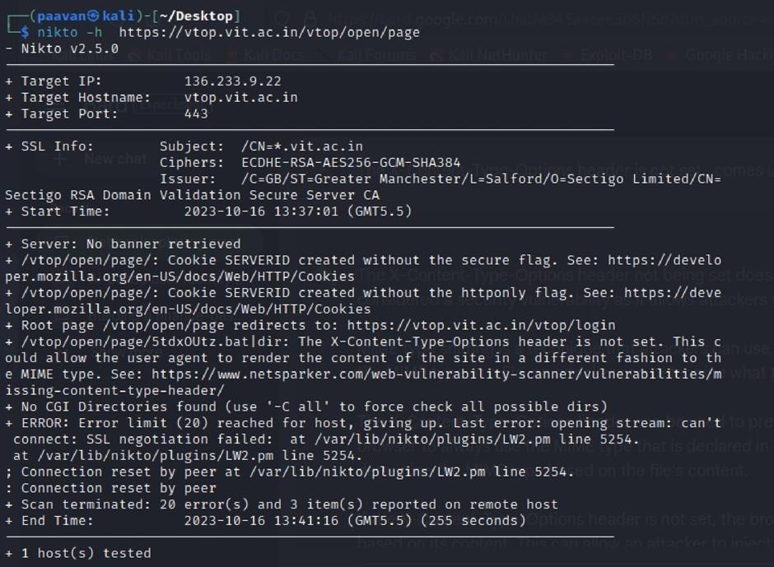

Recommendation:

- Implement "X-Content-Type-Options" Header: Configure the "X-Content-Type-Options" header with the value "nosniff" in your web server or application to prevent content type sniffing.
- Secure SSRF: To directly mitigate SSRF vulnerabilities, ensure proper input validation, access controls, and allow-list-based URL validation to prevent attackers from making unauthorized requests to internal resources.
- Security Headers: Implement other security headers like "X-Frame-Options" and "Content-Security-Policy" to further enhance security and mitigate various types of web-based attacks.
While the "X-Content-Type-Options" header may not be a direct countermeasure to SSRF, it is a valuable security control that, when configured correctly, can help protect against content type- based attacks that may be exploited in SSRF scenarios.
4) Vulnerability Name: Denial of Service

CWE - 400: Uncontrolled Resource Consumption

Description: A Denial of Service (DoS) attack is intended to make a system, website, application, or server unavailable for its normal use. Attackers can achieve this by exploiting weaknesses in network protocols, application logic, programming errors, or improper resource management. When a system receives an extremely large number of requests, it may become overloaded and unable to respond to legitimate users. In some cases, the service may stop functioning if a software vulnerability is exploited or if the system fails to properly manage its resources.
During certain DoS attacks, attackers may also attempt to inject or execute malicious code to gain access to sensitive information or run unauthorized commands on the server. These attacks greatly reduce the quality of service for legitimate users by causing long response times, data loss, and interruptions in system availability. As a result, DoS attacks directly affect the reliability and accessibility of online services.
Business Impact: If this vulnerability is successfully exploited, attackers can overload a system or application by generating excessive requests and consuming available resources. This may cause the system to slow down significantly or become completely unresponsive, preventing legitimate users from accessing the service. Important resources such as CPU, memory, and network bandwidth may be exhausted, leading to reduced system performance. In severe situations, the attack may cause system crashes or failures and could potentially result in data loss. Such disruptions can negatively affect business productivity and financial stability. It can also harm the organization’s reputation by reducing customer trust and confidence. In addition, organizations may face compliance issues if service disruptions violate service agreements or industry standards. To reduce these risks, organizations should implement effective resource management, continuous monitoring, and a strong incident response strategy to maintain system availability and service reliability.
Steps to Reproduce: exploit open ports 443 to perform SQL injections, cross-site request forgeries and DDoS attacks.
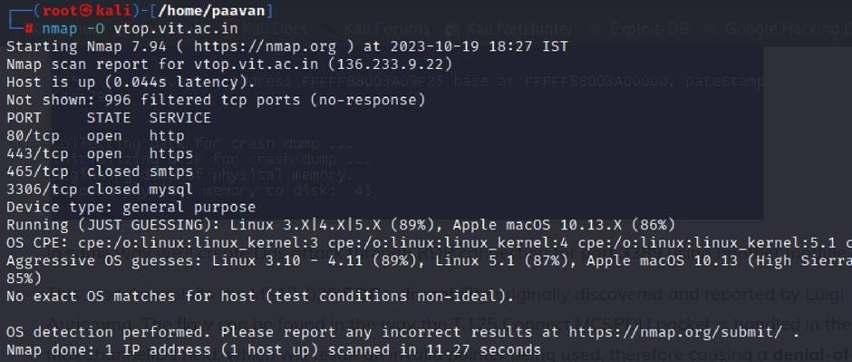

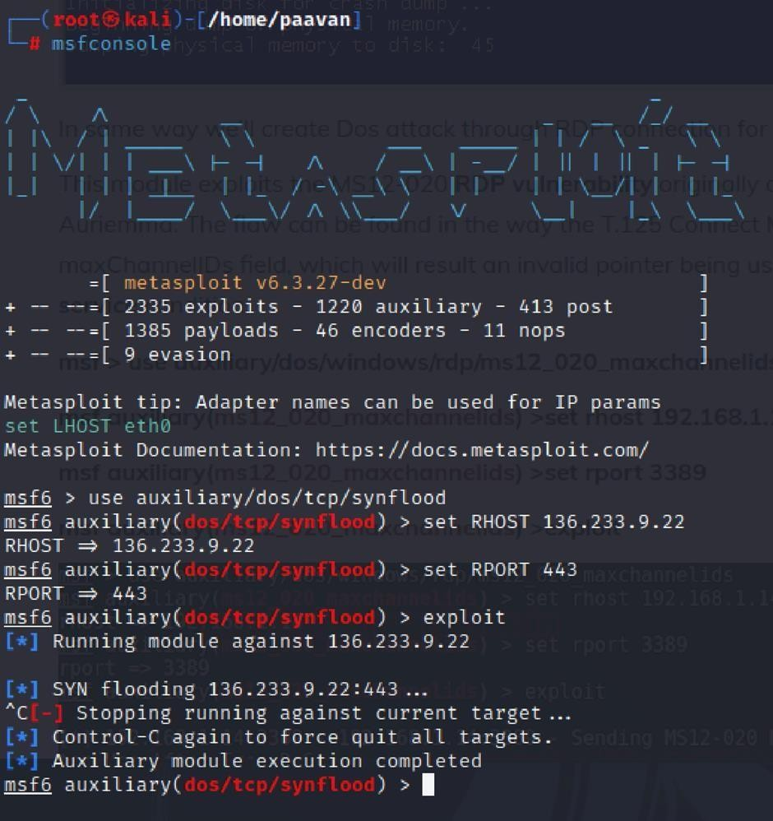
Recommendation: Implement a strong Web Application Firewall (WAF) to filter and control suspicious traffic directed to port 80. The firewall should be configured to detect and block excessive requests or traffic patterns that may indicate an attack. Load balancing techniques can also be used to distribute incoming traffic across multiple servers so that no single server becomes overloaded. In addition, rate limiting and throttling should be applied to restrict the number of requests that a single IP address can send within a specific time period. Network traffic should be monitored regularly, and alert systems should be configured to detect unusual spikes in activity for quick response to possible attacks. It is also important to keep all software and systems updated with the latest security patches to fix known vulnerabilities that attackers might exploit.

5) Vulnerability Name: OS Identification

CWE-200: Exposure of Sensitive Information to an Unauthorised Actor

OWASP Category: A02:2021-Cryptographic Failures

Description: Using a combination of remote probes (e.g., TCP/IP, SMB, HTTP, NTP, SNMP, etc.), it is possible to guess the name of the remote operating system in use. It is also possible sometimes to guess the version of the operating system.
Business Impact: If sensitive information is not properly managed or securely protected, it can result in serious consequences for an organization. These may include financial losses, regulatory fines, and damage to the organization’s reputation. Customers may lose confidence in the company’s ability to protect their personal data, which can lead to reduced business and loss of market share. Legal issues and compliance violations may also arise, creating additional financial and operational burdens. Furthermore, the exposure or theft of intellectual property can weaken a company’s competitive advantage. Addressing such incidents often requires significant remediation efforts, including improving security controls and compensating affected individuals. Therefore, CWE-200 emphasizes the importance of strong data protection practices to maintain an organization’s financial stability, reputation, and long-term sustainability.
Steps to Reproduce: use nmap -O TARGET to enable os detection
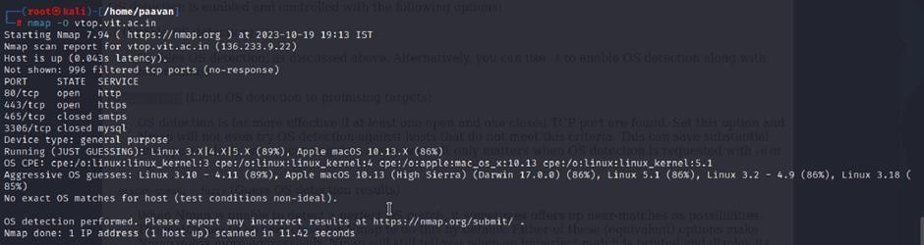
Recommendation: Organizations should implement strong encryption methods to protect data both during transmission and while stored in systems. Strict access control policies and reliable authentication mechanisms should also be enforced to ensure that only authorized users can access sensitive information. Regular vulnerability assessments and penetration testing should be carried out to identify and fix potential security weaknesses. It is also important to provide security awareness training for employees so they understand proper data handling practices and can recognize possible threats. Using data masking techniques in non-production environments and implementing Data Loss Prevention (DLP) solutions can further strengthen data protection. In addition, organizations should follow relevant data protection regulations and maintain a clear incident response plan to effectively handle and reduce the risks of sensitive information exposure.

This is Stage 1 in the process of web application testing and security assessment. In this stage, the OWASP Top 10 is used as a reference to understand common security risks. The OWASP Top 10 is a globally recognized list that highlights the most critical vulnerabilities affecting web applications. Studying these risks helps in identifying potential security weaknesses and improving the overall protection of web applications.

Stage 2
Overview :-

Nessus is a vulnerability scanning tool developed by Tenable, Inc., used to identify security weaknesses in systems and networks. It operates as a remote scanner, which means it does not need to be installed on the target system in order to perform scans. Nessus works by sending different types of probes to the target host to detect possible vulnerabilities. These probes may include network requests, operating system queries, and application-level interactions.
Nessus follows a plugin-based architecture where each plugin is designed to detect a specific vulnerability. Thousands of plugins are available, covering security issues related to operating systems, applications, and network devices. This modular design allows Nessus to regularly update its vulnerability detection capabilities.
During a scan, Nessus first performs host discovery to identify the operating system and services running on the target system. After identifying the host details, it runs multiple plugins to test for known vulnerabilities. If a vulnerability is detected, Nessus generates a detailed report that includes the vulnerability severity, explanation of the issue, and recommended steps to fix the problem.
Nessus can be used to scan different types of targets, such as individual systems, entire networks, or web applications. It also allows scanning of specific ports and services. Users can configure Nessus to perform scans either manually or automatically through scheduled tasks.
Here is a step-by-step explanation of how Nessus works:

- Nessus connects to the target host using a variety of protocols, including TCP, UDP, and ICMP.
- Nessus sends a series of probes to the target host in order to identify its operating system and services.
- Nessus runs a series of plugins to test for vulnerabilities.
- Nessus generates a report that includes the severity of each vulnerability, the steps to reproduce the vulnerability, and the steps to remediate the vulnerability.

Nessus is a useful tool for security professionals to detect and manage vulnerabilities within networks and systems. It is user-friendly and generates detailed reports that help organizations understand security issues and prioritize the necessary remediation actions.

Here are some of the benefits of using Nessus:

- Comprehensive vulnerability coverage: Nessus has over 1200 plugins available, covering a wide range of vulnerabilities in operating systems, applications, and network devices. ● Easy to use: Nessus has a user-friendly interface that makes it easy to configure and run scans.
- Comprehensive reporting: Nessus provides detailed reports that include the severity of each vulnerability,the steps to reproduce the vulnerability, and the steps to remediate the vulnerability.
- Scalability: Nessus can be used to scan a variety of targets, including single hosts, networks, and web applications.
- Flexibility: Nessus can be configured to run scans on a schedule or manually.

Nessus is a powerful tool that can be used to improve the security of any network. It is a valuable asset for any security professional.

Target website :- http://testfire.net/
Target ip address:- 65.61.137.117

List of vulnerability:-
s.no | Vulnerability name | Severity | plugins
1 | TLS Version 1.0 Protocol  Detection | MEDIUM | 104743
2 | TLS Version 1.1 Protocol  Deprecated | MEDIUM | 157288
3 | SSL/TLS Diffie-Hellman Modulus  <= 1024 Bits (Logjam) | LOW | 83875
4 | ICMP Timestamp Request Remote  Date Disclosure | INFO | 10114
5 | Additional DNS Hostnames | INFO | 46180
6 | Apache Tomcat Detection | INFO | 39446
7 | Common Platform Enumeration  (CPE) | INFO | 45590
8 | Device Type | INFO | 54615
9 | HSTS Missing From HTTPS Server | INFO | 84502
10 | HTTP Server Type and Version | INFO | 10107

REPORT: -

1) Vulnerability Name: - 104743 - TLS Version 1.0 Protocol Detection
Severity: - MEDIUM
Plugin: - 104743

Port: - 443
Description: - The remote service accepts connections encrypted using TLS 1.0. TLS 1.0 has a number of cryptographic design flaws. Modern implementations of TLS 1.0 mitigate these problems, but newer versions of TLS like 1.2 and 1.3 are designed against these flaws and should be used whenever possible.
As of March 31, 2020, Endpoints that aren’t enabled for TLS 1.2 and higher will no longer function properly with major web browsers and major vendors.
PCI DSS v3.2 requires that TLS 1.0 be disabled entirely by June 30, 2018, except for POS POI terminals (and the SSL/TLS termination points to which they connect) that can be verified as not being susceptible to any known exploits.
Solution: - Enable support for TLS 1.2 and 1.3, and disable support for TLS 1.0.
Business Impact: - The continued use of TLS 1.0 encryption presents significant security risks due to its known cryptographic weaknesses. These weaknesses increase the chances of data breaches and cyberattacks, which can compromise sensitive information. The use of TLS 1.0 may also lead to non-compliance with industry standards such as PCI DSS v3.2, which requires organizations to stop using this outdated protocol. Failure to comply with these standards can result in regulatory penalties and loss of customer trust. In addition, systems that do not support newer protocols like TLS 1.2 or higher may face compatibility issues with modern web browsers and vendors. This can affect service accessibility and potentially lead to loss of business opportunities and damage to the organization’s reputation. Therefore, upgrading to more secure encryption protocols is essential to maintain strong security and a reliable online presence.

2) Vulnerability Name: - 157288 - TLS Version 1.1 Protocol Deprecated
Severity: - MEDIUM
Plugin: - 157288

Port: - 443
Description: - The remote service is configured to accept connections using TLS 1.1, which is considered an outdated security protocol. TLS 1.1 does not support modern and recommended cipher suites, including stronger encryption methods and authenticated encryption modes such as GCM. Because of these limitations, the protocol cannot provide the same level of security as newer versions. As of March 31, 2020, systems that do not support TLS 1.2 or higher may experience compatibility issues with major web browsers and service providers. Continuing to use TLS 1.1 may therefore reduce system security and affect the reliability of secure communications.
Solution: - Enable support for TLS 1.2 and/or 1.3, and disable support for TLS 1.1.
Business Impact: - The continued use of TLS 1.1, which does not support modern cipher suites and advanced encryption methods, weakens the organization’s overall security and increases the risk of cyberattacks and data breaches. Systems that are not upgraded to support TLS 1.2 or higher may also face compatibility problems with major web browsers and service providers. This can negatively affect user experience and may result in lost business opportunities. Addressing this vulnerability promptly is important to reduce security risks, maintain secure communication with modern platforms, and protect the organization’s reputation and operational efficiency.

3) Vulnerability Name: - 83875 - SSL/TLS Diffie-Hellman Modulus <= 1024 Bits (Logjam)
Severity: - LOW
Plugin: - 83875

Port: - 443
Description: - The remote host allows SSL/TLS connections that use Diffie-Hellman parameters with a modulus size of 1024 bits or less. Such small key sizes are considered weak and may be vulnerable to cryptographic attacks. Through advanced cryptanalysis techniques, an attacker may be able to determine the shared secret used during the key exchange process within a relatively short period of time, depending on the modulus size and available computational resources. If this occurs, the attacker may be able to decrypt the communication or compromise the integrity of the connection, potentially exposing sensitive information transmitted between systems.
Solution: - Reconfigure the service to use a unique Diffie-Hellman moduli of 2048 bits or greater.
Business Impact: - Allowing SSL/TLS connections that use weak Diffie-Hellman moduli can create security risks for the system. Attackers with enough computational resources may be able to break the shared secret used during the key exchange process within a short period of time. This could allow them to decrypt sensitive information or compromise the integrity of secure communications. Although the severity of this issue may be considered low, it still increases the risk of data exposure and security compromise. Therefore, addressing this vulnerability is important to ensure stronger encryption, protect sensitive data, and maintain user trust in the system.
4) Vulnerability Name: - 10114 - ICMP Timestamp Request Remote Date Disclosure
Severity: - INFO
Plugin: - 10114

Port: - 0
Description: - The remote host responds to ICMP timestamp requests, which allows an attacker to determine the system time configured on the target machine. This information may help an unauthenticated remote attacker when attempting to bypass or weaken time-based authentication mechanisms. Although systems running Windows Vista, Windows 7, Windows Server 2008, or Windows Server 2008 R2 return intentionally inaccurate timestamps, the values are typically still within approximately 1000 seconds of the actual system time, which may still provide useful information to an attacker.
Solution: - Filter out the ICMP timestamp requests (13), and the outgoing ICMP timestamp replies (14).
Business Impact: - This issue does not present an immediate threat to business operations or sensitive data. It allows external users to request the system’s date and time information remotely through ICMP timestamp responses. Although the risk level is relatively low, attackers could potentially use this information for reconnaissance to gather details about the system. For this reason, it is recommended to address this vulnerability as part of overall security improvements in order to limit unnecessary information exposure and reduce the chances of misuse in future attacks.

5) Vulnerability Name: - 46180 - Additional DNS Hostnames
Severity: - INFO
Plugin: - 46180

Port: - 0
Description: - Different hostnames other than the current hostname have been identified by various plugins during the scan. Nessus has compiled a list of alternate hostnames that are associated with the same remote host. These hostnames represent additional domain names that resolve to the same server. In some cases, web servers may host multiple websites using name-based virtual hosting, where different hostnames are mapped to the same server and IP address.
Solution: - If you want to test them, re-scan using the special vhost syntax, such as :
www.example.com [192.0.32.10]
Business Impact: - This issue does not represent an immediate risk to business operations or data security. It simply indicates that additional hostnames associated with the same remote host have been identified, which is common when web servers use name-based virtual hosting. Although this information is not a direct security vulnerability, it can provide insight into the server’s configuration and infrastructure. Organizations may use this information for documentation and system management purposes, but it does not require urgent remediation as a security concern.
6) Vulnerability Name: - 39446 - Apache Tomcat Detection
Severity: - INFO
Plugin: - 39446

Port: - 80
Description: -Nessus was able to detect a remote Apache Tomcat web server.
Solution: - n/a
Business Impact: - This finding is informational and indicates that a remote Apache Tomcat web server has been detected. On its own, this information does not represent a security vulnerability or have a direct impact on business operations. However, it can help network administrators and security teams understand which technologies are being used within the network. Knowing that an Apache Tomcat server is present can assist in managing, monitoring, and securing web applications effectively. Since this is not a direct security risk, it does not require immediate remediation.

7) Vulnerability Name: - 45590 - Common Platform Enumeration (CPE)
Severity: - INFO
Plugin: - 45590
Port: - 0

Description: - By using information obtained from a Nessus scan, this plugin reports CPE
(Common Platform Enumeration) matches for various hardware and software products found on a host.
Note that if an official CPE is not available for the product, this plugin computes the best possible CPE based on the information available from the scan.
Solution: - n/a
Business Impact: - This finding provides information about the hardware and software products detected on a host during a Nessus scan. It lists CPE matches, which are standardized identifiers used to represent specific software and hardware components. Although this does not indicate a security vulnerability, it is useful for asset management and inventory tracking. This information helps administrators understand the technologies running within their network, supporting better resource management and simplifying future maintenance and system updates.
8) Vulnerability Name: - Device Type
Severity: - INFO
Plugin: - 54615

Port: - 0
Description: - Based on the remote operating system, it is possible to determine what the remote system type is (eg: a printer, router, general-purpose computer, etc).
Solution: -
Business Impact: - It allows for the identification of the remote system type, such as a printer, router, or general-purpose computer, based on the remote operating system. While this doesn't pose a direct security threat, it offers valuable insights for network administrators to better understand and classify the devices in their network. This information aids in network management, optimization, and ensures that the right security measures are in place for each device type.

9) Vulnerability Name: - 84502 - HSTS Missing From HTTPS Server
Severity: - INFO
Plugin: - 84502

Port: - 443
Description: -The remote HTTPS server is not enforcing HTTP Strict Transport Security (HSTS). HSTS is an optional response header that can be configured on the server to instruct the browser to only communicate via HTTPS. The lack of HSTS allows downgrade attacks, SSL- stripping man-in-the-middle attacks, and weakens cookie-hijacking protections.
Solution: - Configure the remote web server to use HSTS.
Business Impact: -Indicates that the remote HTTPS server does not enforce HTTP Strict Transport Security (HSTS). HSTS is a crucial security feature that, when configured on the server, instructs web browsers to communicate exclusively via HTTPS, enhancing security. The absence of HSTS potentially exposes the server to downgrade attacks, SSL-stripping man-in-the- middle attacks, and weakens protections against cookie hijacking, posing risks to data confidentiality and user security. Enabling HSTS is essential to ensure a higher level of protection for data transmitted between clients and the server.

10) Vulnerability Name: - 10107 - HTTP Server Type and Version
Severity: - INFO
Plugin: - 10107

Port: - 443
Description: - This plugin attempts to determine the type and the version of the remote web server.
Solution: - N/A
Business Impact: -This relates to the identification of the remote web server's type and version. While this issue doesn't pose an immediate security threat, it can provide valuable information to potential attackers about the server's software stack. Knowledge of the server type and version may aid attackers in exploiting known vulnerabilities specific to that software, making it important to restrict such information from being easily accessible to enhance the server's overall security posture.

Stage-3

Report: -

Title: - Implementing Zero Trust Network Access (ZTNA) with Zscaler: Securing
User-to-Application Connectivity

• Zero Trust Network Access (ZTNA)
Zero Trust Network Access (ZTNA) is an IT security framework that provides secure remote access to an organization's internal applications and data based on clearly defined access control policies. Unlike traditional Virtual Private Networks (VPNs), which grant users broad access to the entire network, ZTNA operates on a "never trust, always verify" principle. It grants users access only to the specific applications they need, and only after their identity and device have been verified.
ZTNA is a critical component of modern security architecture. It helps organizations move away from the concept of a trusted internal network and an untrusted external network (the "castleand-moat" model). By hiding the internal network from the internet and establishing one-to-one, encrypted connections between users and applications, ZTNA drastically reduces the attack surface and stops common threats like lateral movement by attackers.

• The ZTNA Access Cycle
The ZTNA cycle is a continuous process of verifying identity, establishing secure connections, and enforcing policy for every access request. It typically consists of the following steps:
- User Request: A user, from any location (office, home, coffee shop), requests access to a specific internal application (e.g., an HR portal, a finance server, or an internal code repository).

- Identity and Device Verification: Before any connection is established, the ZTNA solution verifies who the user is (via multi-factor authentication, or MFA) and checks the security posture of their device. This includes ensuring the device has up-to-date antivirus, a healthy firewall, and is not compromised.
- Policy Enforcement: The ZTNA solution checks the access policy. Does this specific user, with this specific device, have permission to access the requested application at this specific time?
- Establish Secure Connection: If the policy allows access, the ZTNA solution creates a highly secure, encrypted micro-tunnel between the user's device and the target application.
Crucially, the user never gains access to the underlying network, only to the application itself.
- Continuous Monitoring: The ZTNA solution continues to monitor the connection for anomalies. If the user's behavior becomes suspicious or their device posture changes, the connection can be terminated in real-time.
- Logging and Analytics: All access attempts, successful and failed, are logged and analyzed.
This data is used for auditing, threat hunting, and refining access policies.

• Zscaler (Zscaler Internet Access / Zscaler Private Access)
Zscaler is a cloud-native security platform that delivers its services entirely from the cloud, eliminating the need for on-premises hardware like VPN concentrators. For ZTNA, Zscaler offers Zscaler Private Access (ZPA) . ZPA is a service that provides seamless, identity-based access to private applications without ever placing users on the network.
Zscaler ZPA operates on a simple principle: the application is "inside" the Zscaler cloud, and the user connects to it there. It collects data from a variety of sources, including:
- Identity Providers (IdP): Such as Azure AD, Okra, or Ping Identity, to verify user identities.
- Device Posture Partners: Such as CrowdStrike, Tanium, or Microsoft Defender for Endpoint, to check the health of the endpoint.
- Business Applications: The internal web apps, file servers, and legacy applications hosted in data centers or public clouds (e.g., AWS, Azure).
- Zscaler App Connectors: Lightweight software components deployed in the data center or cloud that initiate outbound connections to the Zscaler cloud, making internal servers invisible to the internet.

Zscaler then enforces policies based on this data, including:
- Identity-Based Access: Policies are built around user and group identities, not IP addresses.
- Application Segmentation: Users are granted access to specific applications, not entire subnets.
- Least Privilege Access: Ensures users have the minimum level of access required to perform their jobs.

• The Zscaler ZTNA Cycle
The Zscaler ZTNA cycle is the practical application of the ZTNA principles using the Zscaler cloud. The cycle typically consists of the following steps:
- User Login and Authentication: A user attempts to access an internal application. They are redirected to their organization's Identity Provider (IdP) for authentication and MFA.
- Device Posture Check (Integration): Zscaler checks with integrated endpoint protection tools to ensure the device is compliant with security policies.
- Policy Lookup and Decision: The Zscaler cloud evaluates the request against the defined access policies. It verifies that the user, device, and context (time, location) are authorized for that specific application.
- Establishing the Micro-tunnel: Once authorized, the Zscaler cloud instructs the user's Zscaler Client Connector and the appropriate Zscaler App Connector in the data center to establish an encrypted connection. The user is now connected to the application.
- Traffic Inspection (Optional): For sanctioned applications, Zscaler can optionally inspect the traffic for data loss prevention (DLP) or to detect malware.
- Logging and Analytics: All activity is logged in the Zscaler cloud portal for reporting, threat hunting, and compliance.

• MISP (Malware Information Sharing Platform) Integration
While Zscaler is a primary access control tool, it can be enhanced by integrating with threat intelligence platforms like MISP.
- Threat Intelligence Feed: MISP can aggregate and share threat intelligence about malicious domains, IPs, and URLs. This list of indicators of compromise (IOCs) can be fed into Zscaler's cloud.
- Proactive Blocking: If a user, even one authorized by ZPA, attempts to access a known malicious site that has been flagged by the MISP feed, Zscaler Internet Access (ZIA) can block the request, preventing a potential infection.
- Enhanced Visibility: Security teams can use MISP to cross-reference Zscaler logs. If a user's behavior is anomalous, the team can check MISP to see if the destination IP or domain is associated with a known threat actor or campaign.
  - Your College Network Information
This infrastructure presents a large attack surface, especially with the need for remote learning and administrative access. The network includes:

  - Core routers and switches
  - Distribution routers and switches
  - Wireless access points
  - Firewalls and Intrusion Detection Systems (IDS)
  - Internal Application Servers: Hosting the student information system, library resources, research data repositories, and administrative portals.
  - Legacy VPN Concentrator: Currently providing broad network-level access for faculty and staff working remotely.
The need for ZTNA arises from the limitations of the current VPN model:
  - Over-permissioned Access: Once on the VPN, a faculty member's compromised laptop could potentially scan and attack the entire internal network (lateral movement).
  - Hidden Applications: Some research applications need to be accessed by external collaborators without granting them full network access.
  - User Experience: The legacy VPN can be slow and cumbersome, often requiring users to route all their internet traffic through the university.
  - How you think you deploy ZTNA using Zscaler in your college
To deploy Zscaler ZTNA (ZPA) in your college, you would start by identifying the specific applications that need to be secured and the user groups that need access to them. This is a shift from securing the network to securing access to applications.
The plan would need to include the following:
- Application Discovery: Catalog all internal applications (e.g., ERP, library system, research servers, file shares) and identify which ones are currently exposed via the VPN.
- User Segmentation: Define user groups (e.g., Students, Faculty - Research, Faculty - Admin, IT Staff, External Collaborators) and the specific applications each group needs.
- Deploying Zscaler App Connectors: Install lightweight App Connector VMs in the university's data center. These connectors will establish outbound connections to the Zscaler cloud, making the application servers invisible to the public internet.
- Integrating Identity Provider: Connect Zscaler to the university's existing Identity Provider (e.g., Microsoft Azure AD) to leverage current usernames, passwords, and MFA policies.
- Configuring Access Policies: Create granular policies in the Zscaler admin portal. For example: "The 'Faculty' group can access the 'ERP Application' from any device that has antivirus enabled, after MFA."

- Deploying Zscaler Client Connector: Students, faculty, and staff will install the Zscaler Client Connector on their laptops and mobile devices. This small client intelligently routes traffic for private applications through ZPA and public traffic through ZIA.
• Threat Intelligence
In the context of Zscaler and ZTNA, threat intelligence is used to understand who is trying to access what, and from where. It helps move beyond simple identity checks to a more contextual understanding of risk. Sources include:
- Zscaler Cloud Logs: Internal logs provide real-time data on who is accessing which applications, from which locations, and on what devices.
- External Threat Feeds (MISP): Information about new malware campaigns, phishing kits, or command-and-control servers being used by attackers.
- Identity Provider Logs: Anomalies in login attempts, such as a user logging in from two geographically impossible locations in a short time, can signal a compromised account.
This intelligence is used for:
- Adaptive Access Control: If threat intelligence suggests a user's location is high-risk, Zscaler can step-up authentication requirements or block access entirely.
- Hunting for Compromised Accounts: Analysts can use Zscaler logs to see if a user is suddenly accessing applications they never have before, which could be a sign of credential theft.
- Blocking Malicious Communication: Threat intelligence feeds can be used by Zscaler Internet Access (ZIA) to block outbound connections to known malicious sites, even if they originate from a user inside the university.
• Incident Response (Adapted for ZTNA)
Incident response in a ZTNA model is faster and more targeted because the environment is inherently more controlled.
- Detection: The SOC team detects an anomaly. For example, a faculty account is downloading an unusually high volume of data from a research server at 3 AM. Zscaler logs provide the exact details: the user, the device, the application, and the amount of data transferred.
- Containment: The SOC team can instantly isolate the user. In the Zscaler portal, they can simply deactivate that user's access or block their specific device. Because there is no networklevel access, this action immediately severs all connections to every application, preventing lateral movement.
- Eradication: The compromised device is taken offline for malware scanning and cleaning by the IT helpdesk.
- Recovery: Once the device is clean and the user's password is reset, the Zscaler policy is reenabled, granting the user access again.
- Post-incident review: The security team analyzes the logs to understand how the account was compromised (e.g., a phishing email) and updates Zscaler policies, perhaps by adding a block for similar malicious domains or tightening access rules for that specific research application.
Benefits of this incident response approach:
- Near-Instant Containment: Actions take seconds in a cloud dashboard, not minutes or hours configuring firewall rules.
- No Lateral Movement: The attacker is contained to the single compromised application, protecting the rest of the university's network.
- Granular Forensics: Zscaler provides a detailed audit trail of every connection, making investigations faster and more accurate.
- Compliance: This model helps demonstrate compliance with data protection regulations by proving that access to sensitive student or research data is tightly controlled and audited.
• Understanding about the tool (Zscaler ZPA)
Zscaler Private Access (ZPA) is a cloud service that embodies the ZTNA principle of "connect a user to an app, not the network." Here are the key things to understand:
- It is "Application-Centric," Not "Network-Centric": You define policies based on applications (e.g., "SAP Server 01"), not network constructs like IP subnets. This aligns security with how businesses actually operate.
- It Hides the Network: ZPA uses App Connectors inside your data center that only make outbound connections to the Zscaler cloud. Your internal servers never need to open inbound firewall ports, making them invisible to port scanners and attackers on the internet.
- It uses a "Dark Cloud" Approach: To an external scanner, the organization's applications simply don't exist. They only become visible to authorized users after a multi-step verification process.
- It Provides a Superior User Experience: Users don't have to mess with clunky VPN clients. The Zscaler Client Connector works silently in the background. For web apps, access can even be agentless, requiring only a modern browser.
- It is Inherently Scalable: Because it's a cloud service, ZPA scales instantly to handle thousands of concurrent users, unlike a legacy VPN appliance that needs to be manually upgraded.

Conclusion: -

In conclusion, exploring the realm of AI for web security using IBM QRadar has been an insightful journey through various stages.

In Stage 1, understanding web application testing unveiled the critical importance of assessing vulnerabilities and ensuring the security of web-based systems. This foundational knowledge served as a cornerstone for comprehending the subsequent stages.

Stage 2 delved into the intricacies of Nessus reports, emphasising the significance of detailed vulnerability assessments. Analysing these reports provided valuable insights into potential threats, enabling informed decision-making for robust security measures.

Stage 3 introduced the pivotal concept of Zero Trust Network Access (ZTNA) and its implementation using Zscaler Private Access (ZPA). It demonstrated a paradigm shift from traditional VPN-based network access to secure, identity-based user-to-application connectivity. The solution showcased the power of hiding internal applications from the internet, enforcing granular access policies, and eliminating lateral movement. This underscores the need for modern, proactive cybersecurity strategies in an era of remote work and cloud adoption.

Considering the future scope, Stage 1 illuminated the evolving landscape of web application testing. With advancements in AI, there is a promising avenue for more sophisticated testing methodologies, ensuring even higher levels of security for web applications.

Stage 2 highlighted the future trajectory of the testing process, indicating a shift towards more automation and integration of AI-driven tools. This evolution promises quicker, more accurate vulnerability assessments, enhancing overall cybersecurity postures.

Stage 3 illuminated the future potential of Zero Trust Network Access (ZTNA) and Zscaler technologies. With AI integration and machine learning, these systems are poised to become more intelligent and adaptive, enabling real-time risk assessment based on user behavior and device posture. Enhanced automation in policy enforcement, predictive analytics for threat detection, and improved scalability are anticipated, empowering organizations to stay ahead of sophisticated cyber threats in an increasingly distributed world.
In essence, the project not only provided a deep understanding of the current state zero trust using ZSCALER but also offered a glimpse into the exciting future of cybersecurity. Embracing these advancements will be crucial for organisations aiming to fortify their digital landscapes in the face of ever-evolving cyber threats.

Future Scope: -

Future of web application testing

The future of WAT is bright, as web applications become increasingly complex and sophisticated. Organizations are increasingly reliant on web applications to conduct business, and they need to be confident that their web applications are secure and reliable.

Here are some of the key trends that are expected to shape the future of WAT:

- Increased focus on security: Security is a top priority for all organizations, and WAT is essential for identifying and mitigating security vulnerabilities. In the future, we can expect to see even more emphasis on security testing, as web applications become increasingly targeted by cyberattacks.
- Rise of artificial intelligence (AI) and machine learning (ML): AI and ML are already being used in WAT, and their role is expected to grow in the future. AI and ML can be used to automate repetitive tasks, such as test case generation and execution. They can also be used to identify complex patterns and anomalies that may be difficult to detect with traditional testing methods.
- Shift to cloud-based testing: More and more organizations are moving their web applications to the cloud. This trend is driving the growth of cloud-based WAT platforms. Cloud-based testing platforms offer a number of advantages, such as scalability, flexibility, and cost-effectiveness.
- Increased focus on user experience (UX) testing: UX testing is essential for ensuring that web applications are easy to use and meet the needs of users. In the future, we can expect to see more focus on UX testing, as organizations increasingly recognize the importance of providing a positive user experience.

Future scope of the testing process

The future scope of the testing process is bright, as software becomes increasingly complex and sophisticated. Organisations are increasingly reliant on software to conduct business, and they need to be confident that their software is high-quality and reliable.
Here are some of the key trends that are expected to shape the future of the testing process:

- Increased focus on continuous testing: Continuous testing is a methodology that involves testing software throughout the SDLC, from development to deployment. This helps to identify defects early and prevent them from causing problems later in the development process.
- Rise of AI and ML: AI and ML are already being used in the testing process, and their role is expected to grow in the future. AI and ML can be used to automate repetitive tasks, such as test case generation and execution. They can also be used to identify complex patterns and anomalies that may be difficult to detect with traditional testing methods.
- Shift to cloud-based testing: Cloud-based testing platforms offer a number of advantages, such as scalability, flexibility, and cost-effectiveness. This is driving the growth of cloud-based testing platforms.
- Increased focus on testing automation: Testing automation is the use of software to execute test cases without human intervention. Testing automation can help to save time and resources, and it can also help to improve the quality and efficiency of testing.

Future scope of SOC / SEIM:-

The future scope of Zero Trust Network Access (ZTNA) and the broader Zero Trust framework is poised for significant evolution, driven by emerging technologies and changing threat landscapes:
- AI-Driven Zero Trust (AI-ZTA): Future Zero Trust implementations will leverage advanced AI and deep learning to move beyond static policies. Systems will continuously learn user behavior, predict anomalous activities before they occur, and dynamically adjust access privileges in real-time based on contextual risk, creating a truly "adaptive" security posture.
- Integration with Edge Computing and IoT: As organizations deploy more IoT devices and edge computing nodes, Zero Trust principles will extend to these resource-constrained environments. Expect the development of lightweight Zero Trust agents and protocols that can authenticate and secure machine-to-machine (M2M) communication at the edge, preventing large-scale botnet attacks.
- Identity-Centric Everything: The future will see identity become the ultimate security perimeter. Zero Trust will evolve to incorporate advanced identity verification methods, including continuous behavioral biometrics (keystroke dynamics, gait analysis) and decentralized identity solutions using blockchain, ensuring that the user behind the session is verified at all times.
- Convergence with SASE Architecture: Zero Trust will be a core component of the Secure Access Service Edge (SASE) framework. This convergence will provide organizations with a unified, cloud-delivered stack that combines ZTNA, Secure Web Gateways (SWG), Cloud Access Security Brokers (CASB), and Firewall-as-a-Service (FWaaS), simplifying management and ensuring consistent security for all users, regardless of location.

- Zero Trust for Operational Technology (OT) and Critical Infrastructure: Sectors like energy, manufacturing, and healthcare will increasingly adopt Zero Trust to protect critical infrastructure. Future scope includes air-gapped Zero Trust solutions and specialized protocols designed to secure legacy industrial control systems (ICS) and SCADA environments from nation-state attacks.
- Automated Threat Hunting and Response: Future Zero Trust platforms will integrate with Security Orchestration, Automation, and Response (SOAR) tools to enable automated threat hunting. Upon detecting a compromised identity or device, the system will not just block access but automatically initiate investigation playbooks, isolate affected systems, and even roll back malicious changes.

Topics explored: -

Data Collection and Aggregation, Standardization and Normalisation, Enrichment and Analysis,
Sharing and Distribution, Integration with Security Tools, Customization and Flexibility,
Automation and Orchestration, Community Involvement, Incident Response Support, Threat Intelligence Feeds, Soc and Siem

Tools explored: -

Nmap, Metasploit, Nessus, Kali Linux, OWASP ZAP, Burp Suite

THE END

